1. Given the provided data, what are three conclusions we can draw about Kickstarter campaigns?
   * Theater category had the highest number of successful campaigns and Music had the highest success rate against the total number of campaigns
   * Play sub-category had the highest number of successful campaigns
   * The success rate went down in the 2nd and 3rd quarters.

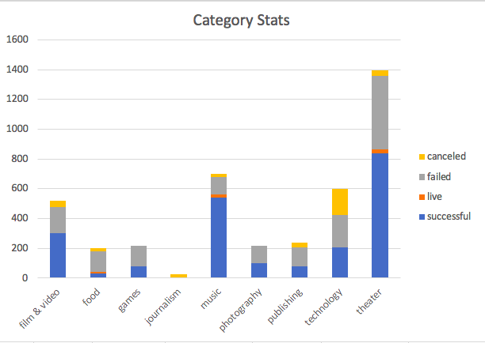

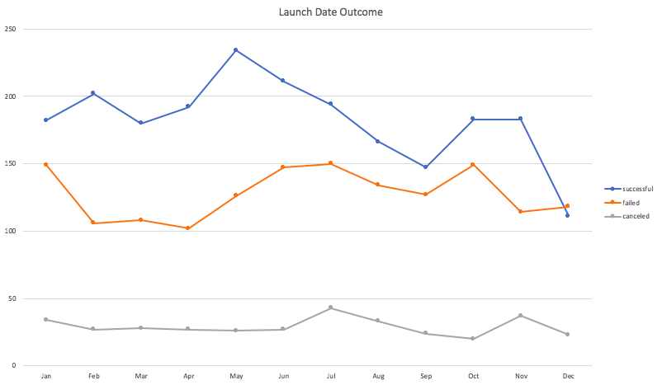

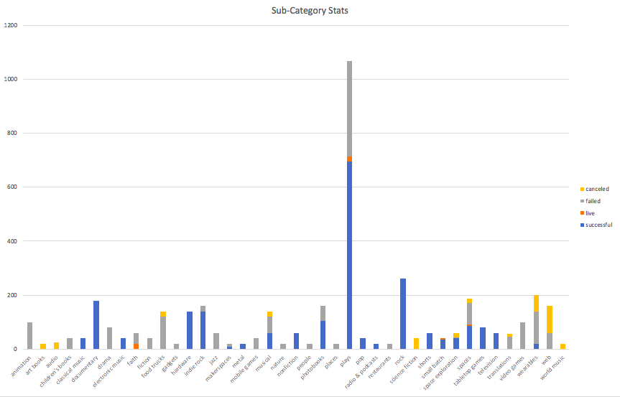

1. What are some limitations of this dataset?

Different Currency Rates make it difficult to analyze the donation amount

Knowing target viewers may reveal additional information such as by using viewer ratings (PG, PG13, etc.)

1. What are some other possible tables and/or graphs that we could create?

Percent Funded per Category, Percent Funded per Sub-Category, Total Donation per Category, Total Donation per Sub-Category, Total Donation by Total Number of Backers, Outcome by Country,

Outcome by Staff_Picked, Outcome by Spotlight